Model Initialization: The simulation picks a random state and loads its rent data and growth rates. It sets national vacancy/supply growth parameters and prints summary stats. It then creates neighborhoods with random amenity scores, and for each neighborhood instantiates many HousingUnits (random room types/rents) and corresponding Landlords. Households are generated with incomes and preferences sampled from distributions; each is assigned (if affordable) to an initial vacant unit via hh.move_to(unit). Get state data for mean rents and growth rate Neighborhood class
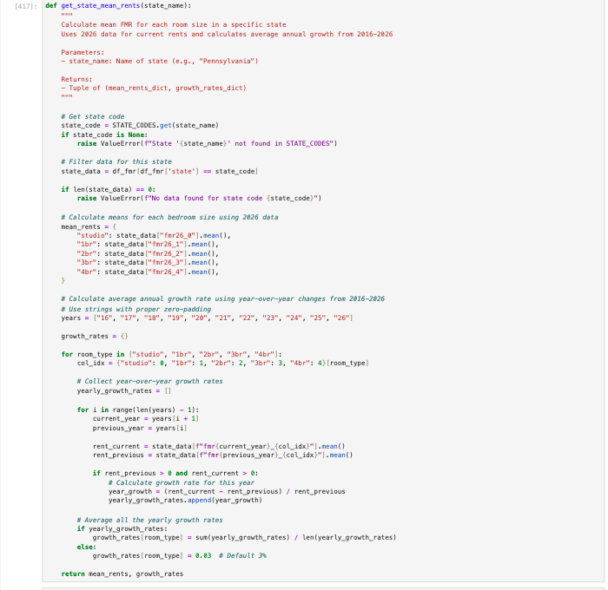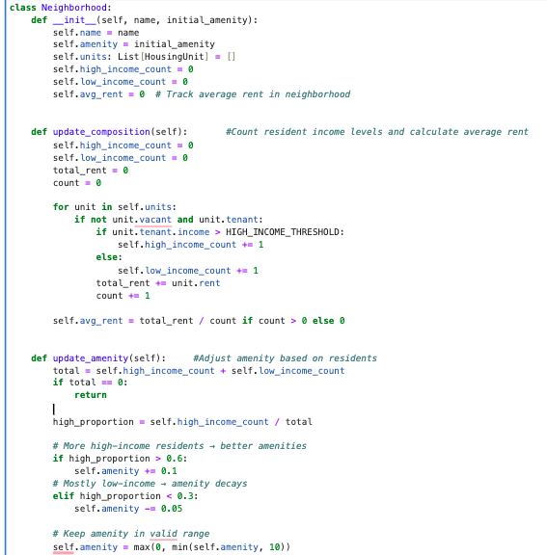
Initialization
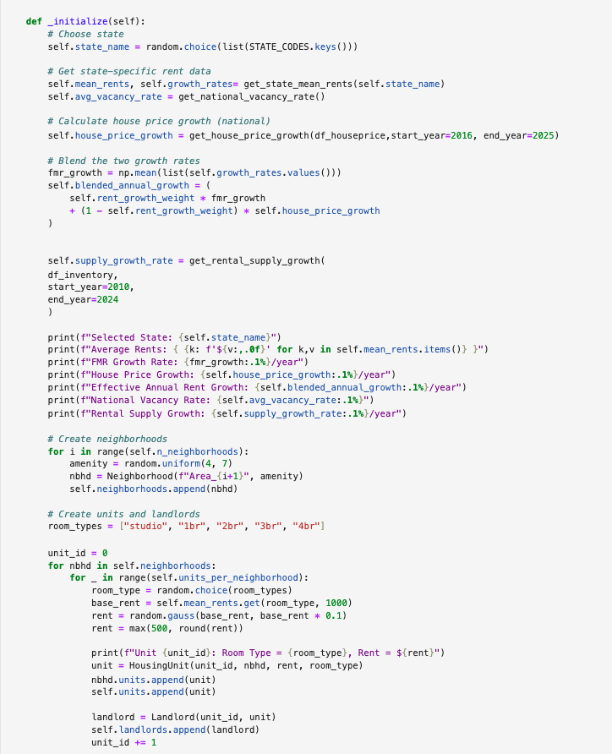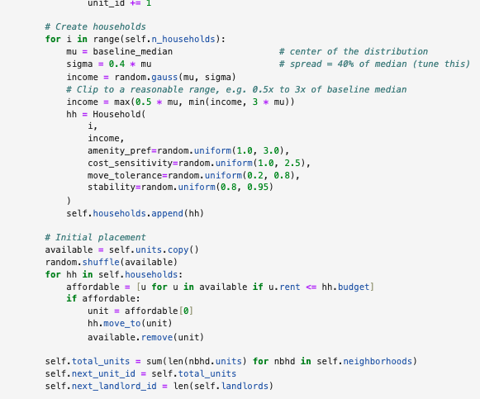
Household class
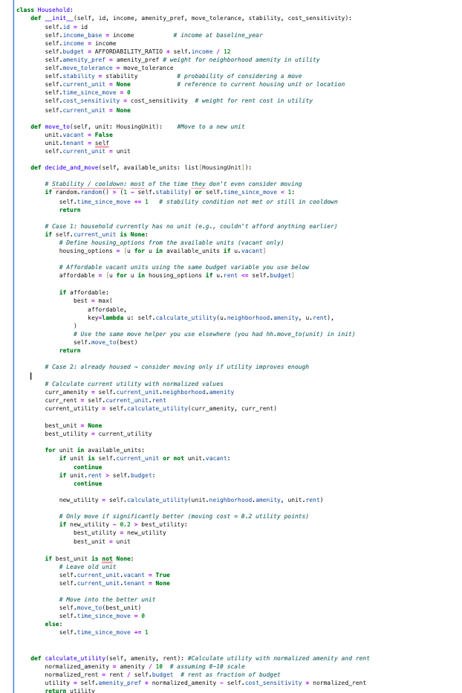

Household & Unit Dynamics: A Household has income, budget (30% rule), amenity preference, cost sensitivity, and stability parameters. Its decide_and_move() method is called each step: with some probability it considers moving, computes a utility (normalized amenity minus cost) for affordable units, and moves to a better unit if utility improves (respecting moving costs and cooldown). HousingUnits track rent, vacancy, and tenant reference.
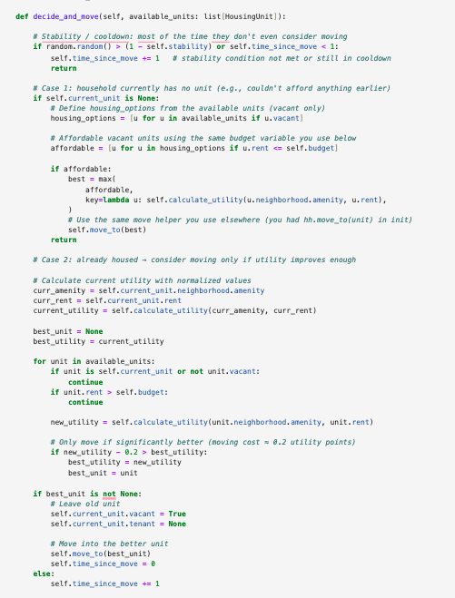
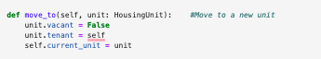

Rent Adjustment: Each month, landlords run adjust_rent(). If a unit is vacant or congested, rents are lowered; if occupied steadily, rents rise by the market growth rate (from FMR/price data) or extra in tight markets. The code uses neighborhood vacancy and demand (high/low-income count) to modulate rent up/down proportionally.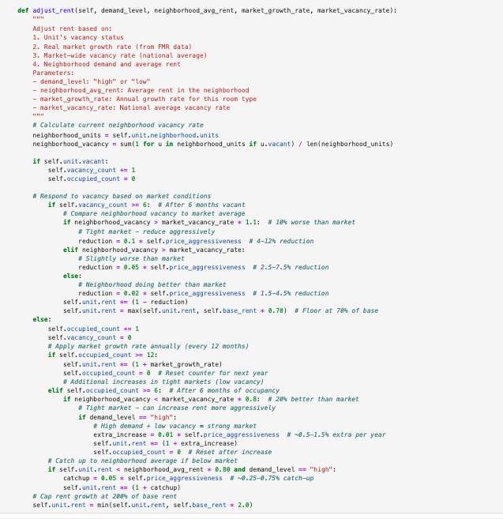

Simulation Loop: The HousingSimulation.run() loop iterates for each time step. Yearly, it may call add_new_units()based on exogenous supply growth. Each step calls update_household_incomes(), then all households decide_and_move(), then all landlords adjust_rent(), and neighborhoods update (income composition and amenity). After each step, average rent, amenity scores, and segregation (income variance) are recorded.
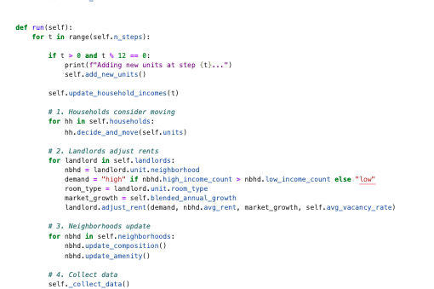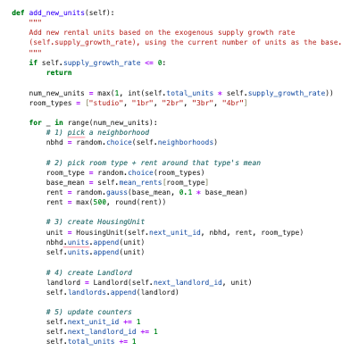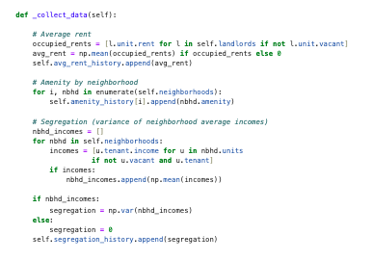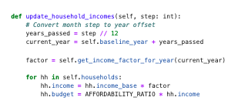
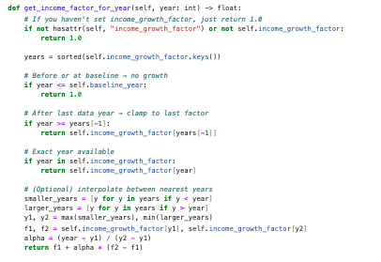
Calibration: A helper function run_single_sim(weight) fixes random seeds, creates a HousingSimulation with a given rent_growth_weight, runs it, and computes model vs. target (FMR) annual rent growth. The calibrate_rent_growth_weight() function loops over candidate weights, prints errors/accuracy, and selects the weight that minimizes growth error. Finally, a simulation is rerun with the best weight and results printed.
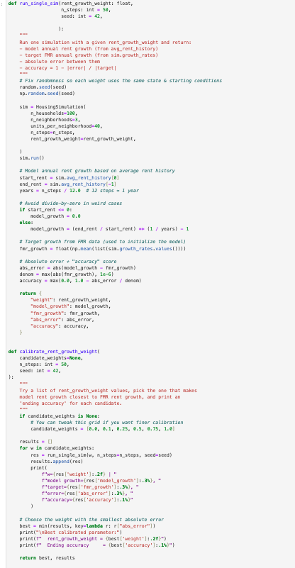
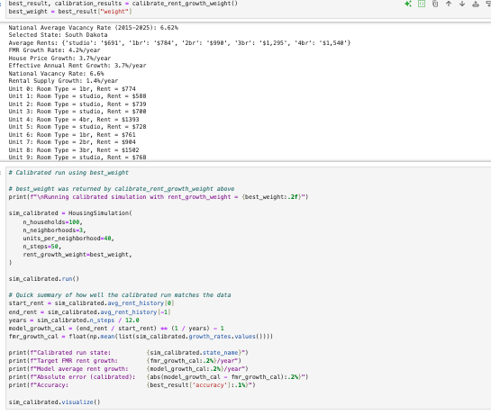

Outputs & Visualization: After running, the model can call sim.visualize(). This produces plots of average rent over time, amenity evolution by neighborhood, a scatter of final incomes vs. rents (with a 30%-of-income line), and a distribution of rent burden by income group. These outputs summarize how rents and segregation evolved and how households’ affordability distributed at the final step.
